Sorry for those lack of functionality I will try to make those in future - right now I didn’t have enough time to do so much, but there are some concerns regarding the evaluation:

1) SORRY I couldn’t make the delete and retweet functionality and the UI is also not good, and the success and error messages are in the console not in the notifications, and lack of editing in the profile.

2) The success and error messages are in the console not in the UI that’s my bad

3) the Signin the previous user created is working fine in me I I'm sharing pictures that show the tweets are done by the user after the previously created ones. the user data is retained in the database you can log in your previously created user.

4) User cannot register twice themselves as shown in the pictures below that a user will get error messages if he tries to do so. The problem is the space is count as a letter so if you create a user with an space added to the username or the mail id it will count it as the new user it , sorry for that I will try to fix it in future - this is the same problem in sign in if we put the space it doesn't login because it count it as the letter.

5) Tweets of other user - the tweet of the other user is show as shown In the pictures below in different tabs

- explore all the tweets that are been tweeted on the app are shown.

- in home the tweets done by user and the people he follows are shown.

-in profile only the tweets done by the user is shown so it's working fine for me.

Sorry for this inconvenience, and I am sharing all the pictures of the proof of working, and the extra functionality will be implemented later, lack of time it is right now.

Also giving you these five ids to work with –

Signin with the username and password

First account

Username – Abhyanshu

Email – Abhyanshu@gmail.com

Password – Abhyanshu

Second Account

Username – Suresh

Email – Suresh@gmail.com

Password - Suresh

Third Account

Username – Mukesh

Email – Mukesh@gmail.com

Password – Mukesh

Fourth Account

Username – Ramesh

Email – Ramesh@gmail.com

Password - Ramesh

Fifth Account

Username – CarryDoe

Email – CarryDoe@gmail.com

Password - carrydoe

These all-screen shots are to show that the tweets retain, and id retain is working - I don’t know maybe there is some issue can because of the devices but I think these will give you good understanding of this apps functioning

This is the screen shot to show that the different users are being retained and can be login again and see tweets you created :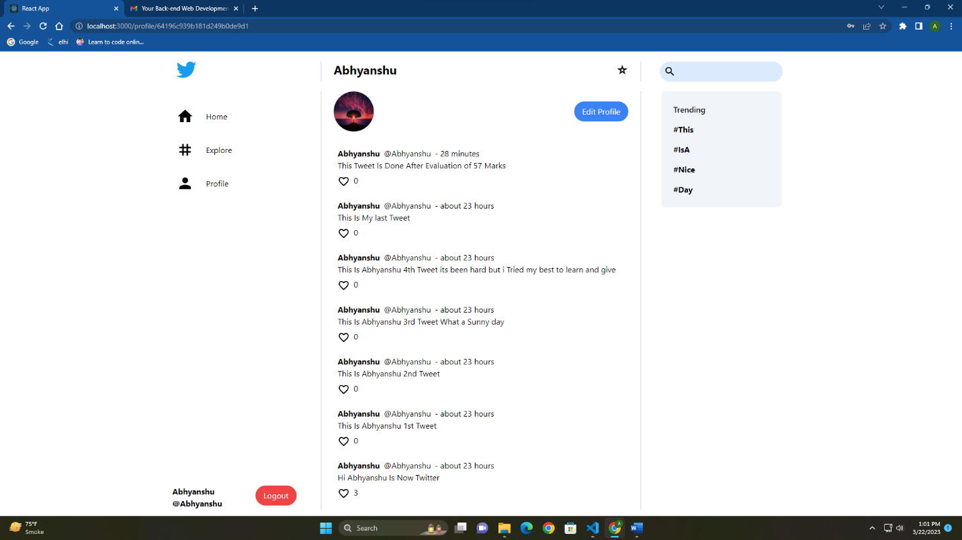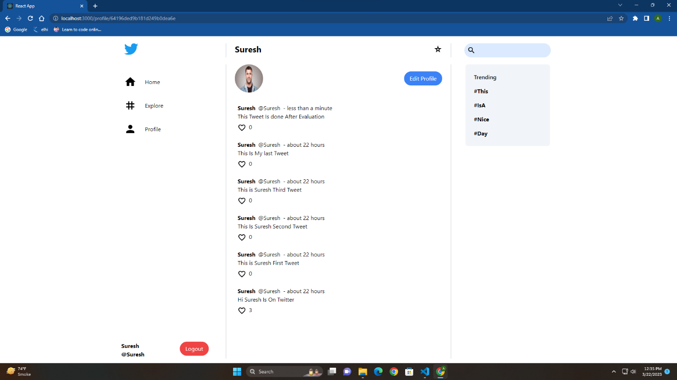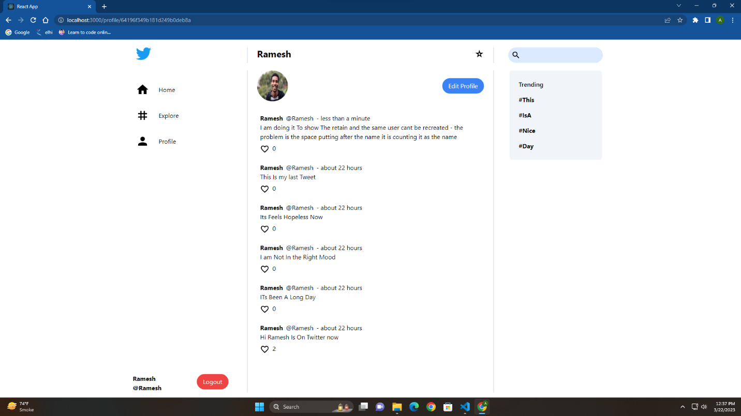

This is the screen shot to show that here on home you will see all the tweets you created and tweets of people you follow:

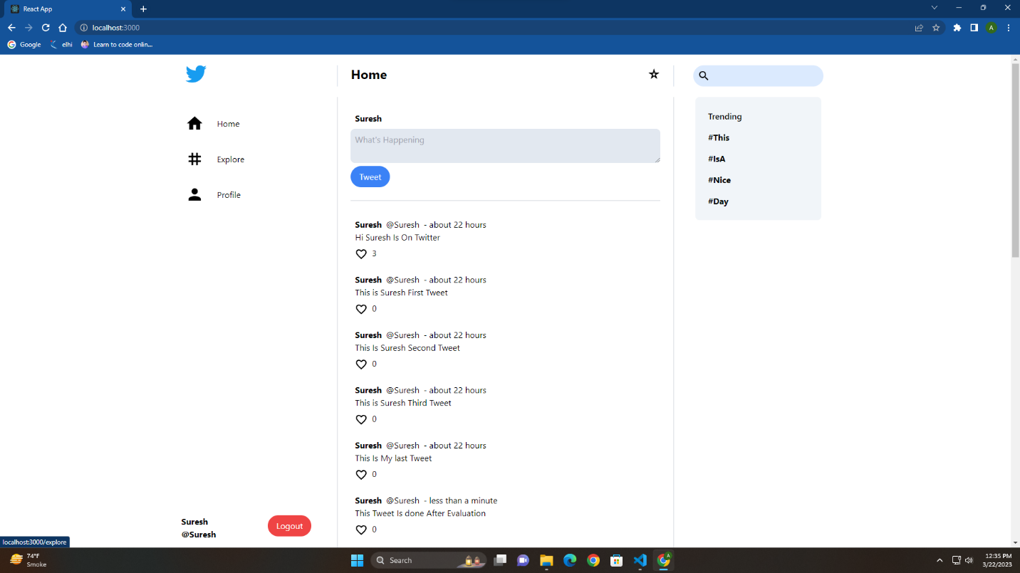

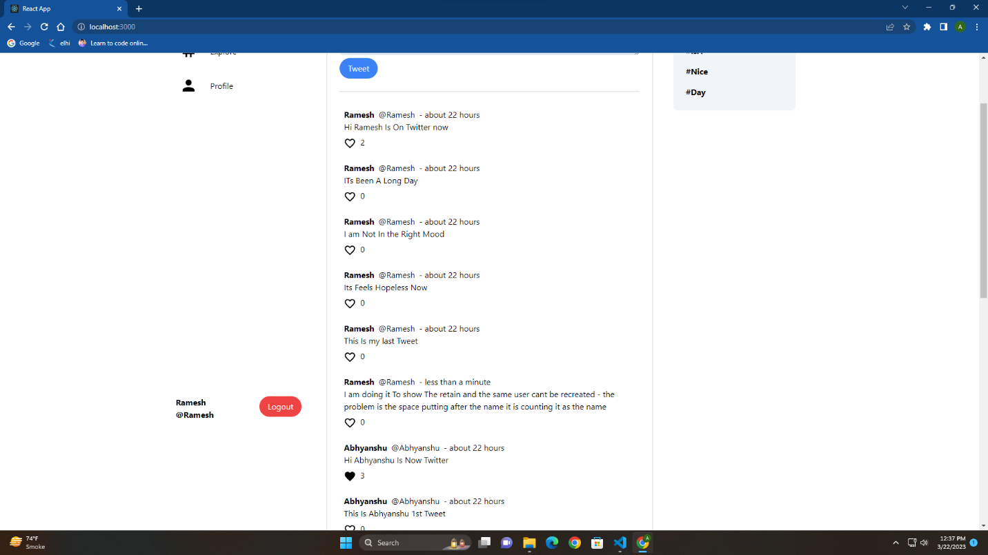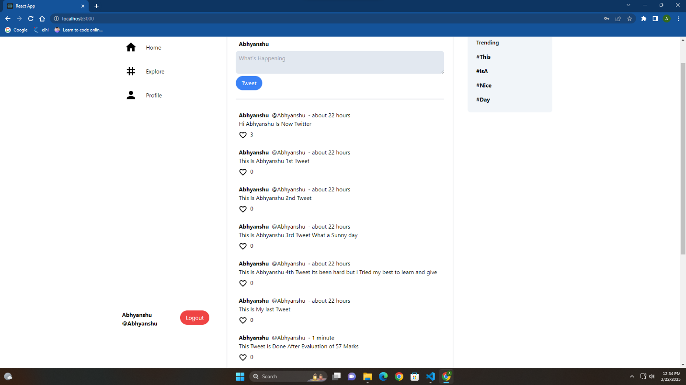

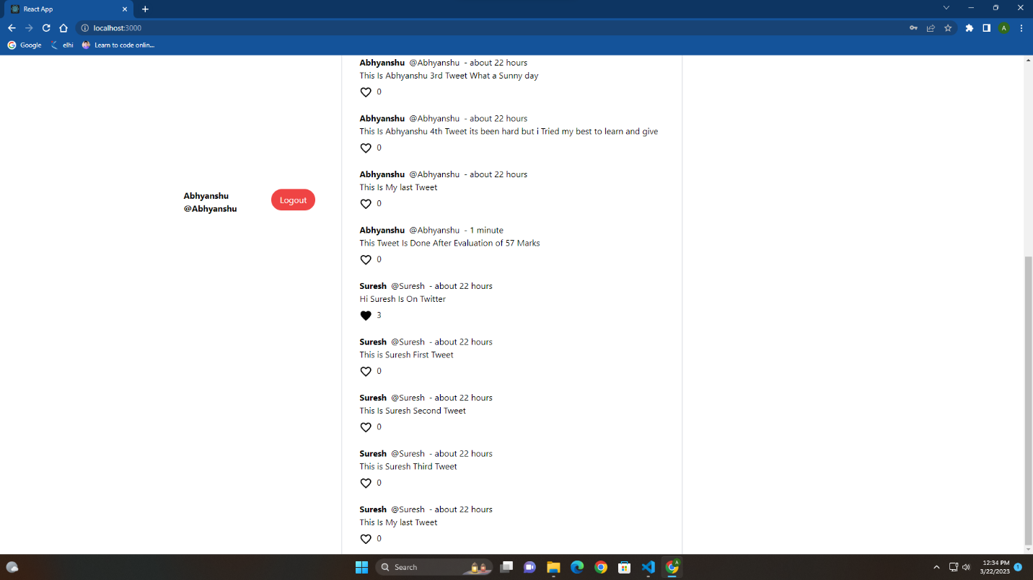

This is the screen shot to show that you can see everyone tweets of the person who exists and tweeted on the app on the:

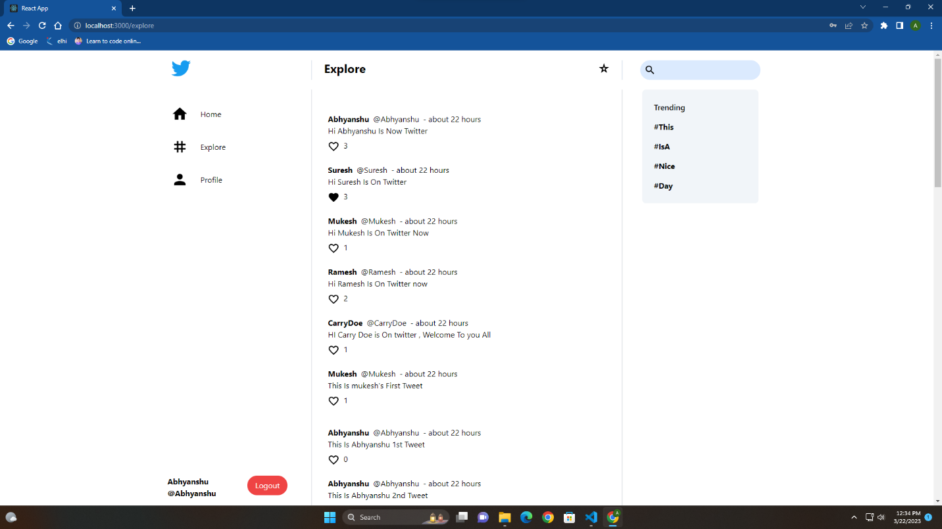

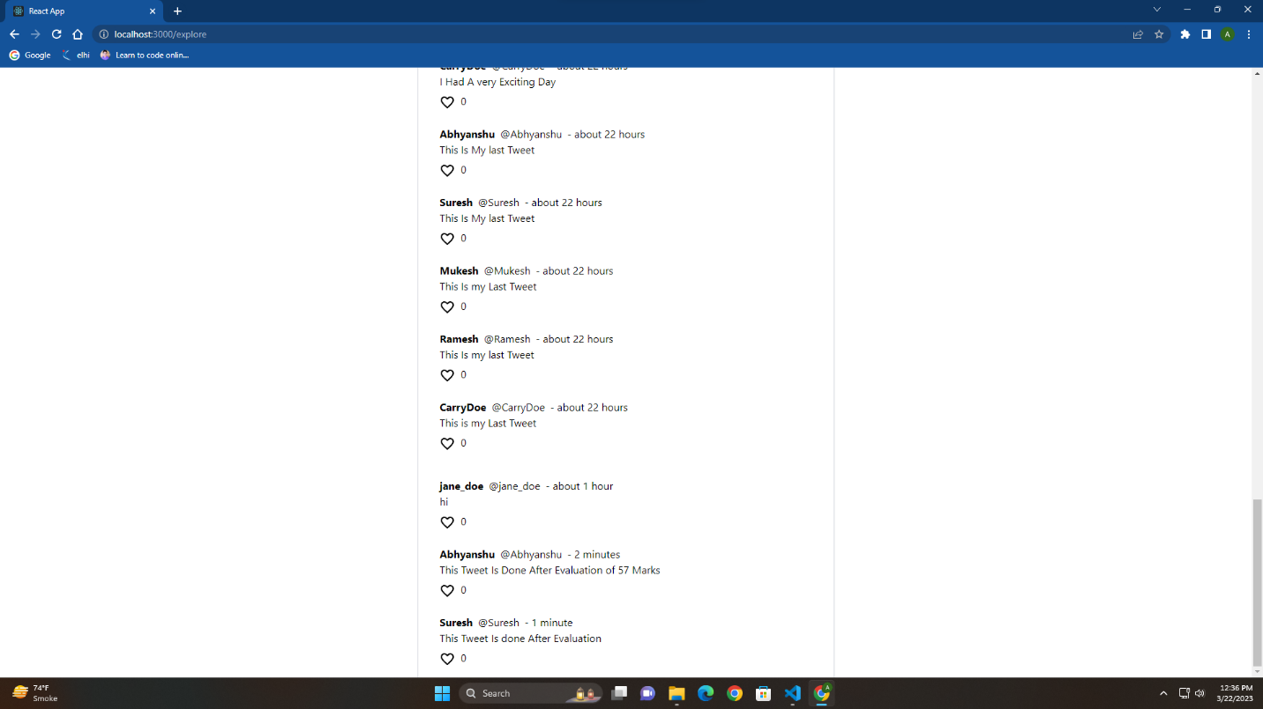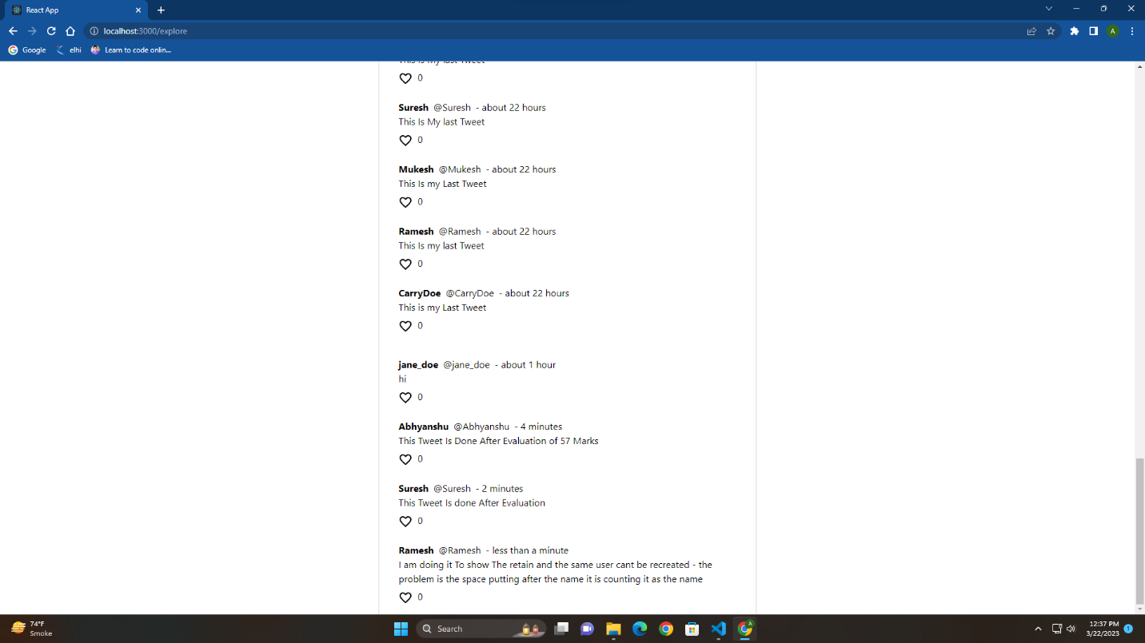

This is Screenshot that how you cannot sign up with the same account that been exist

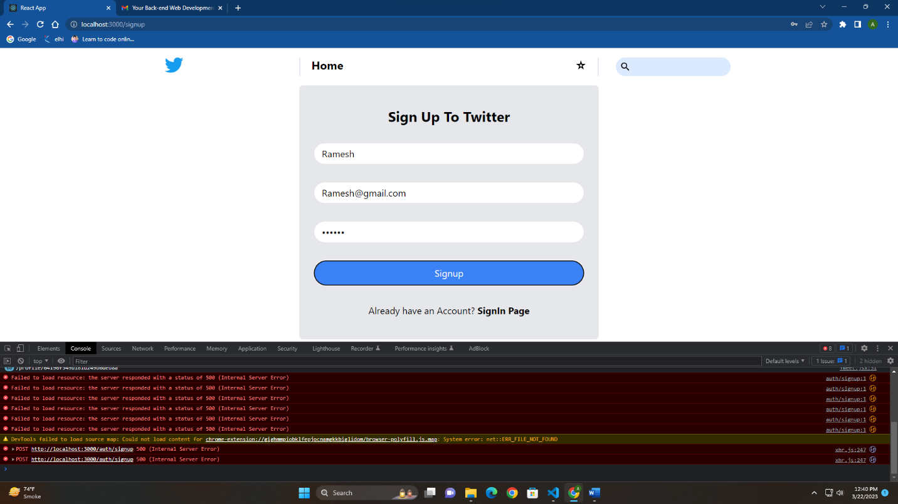

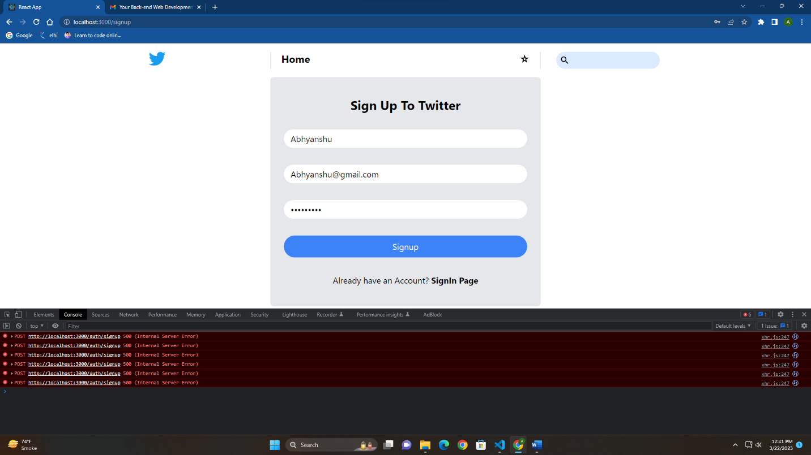

This is the screen shot that you cannot login with wrong name or password:

